# NO.1

**AIM**: program to test different operators(arithmetic).

**Procedure:**

#!/bin/bash

read -p "enter first no: " a

read -p "Enter second no: " b

add=$((a + b))

echo "added values are $add"

sub=$((a - b))

echo "subtracted values are $sub"

mul=$((a * b))

echo "product of values are $mul"

div=$((a / b))

echo "quotient of values are $div"

mod=$((a % b))

echo "modulus of values are $mod"

if [ $a == $b ]

then

echo "a and b are equal"

fi

if [ $a != $b ]

then

echo "a and b are not equal"

fi

((++a))

echo "after increment operator on a value is $a"

((--b))

echo "after decrement operator on b value is $b"

**output:**

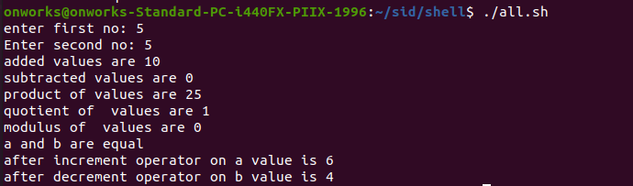

# Result

The program was executed and the result was successfully obtained. Thus CO3 was obtained